**DAILY ONLINE ACTIVITIES SUMMARY**

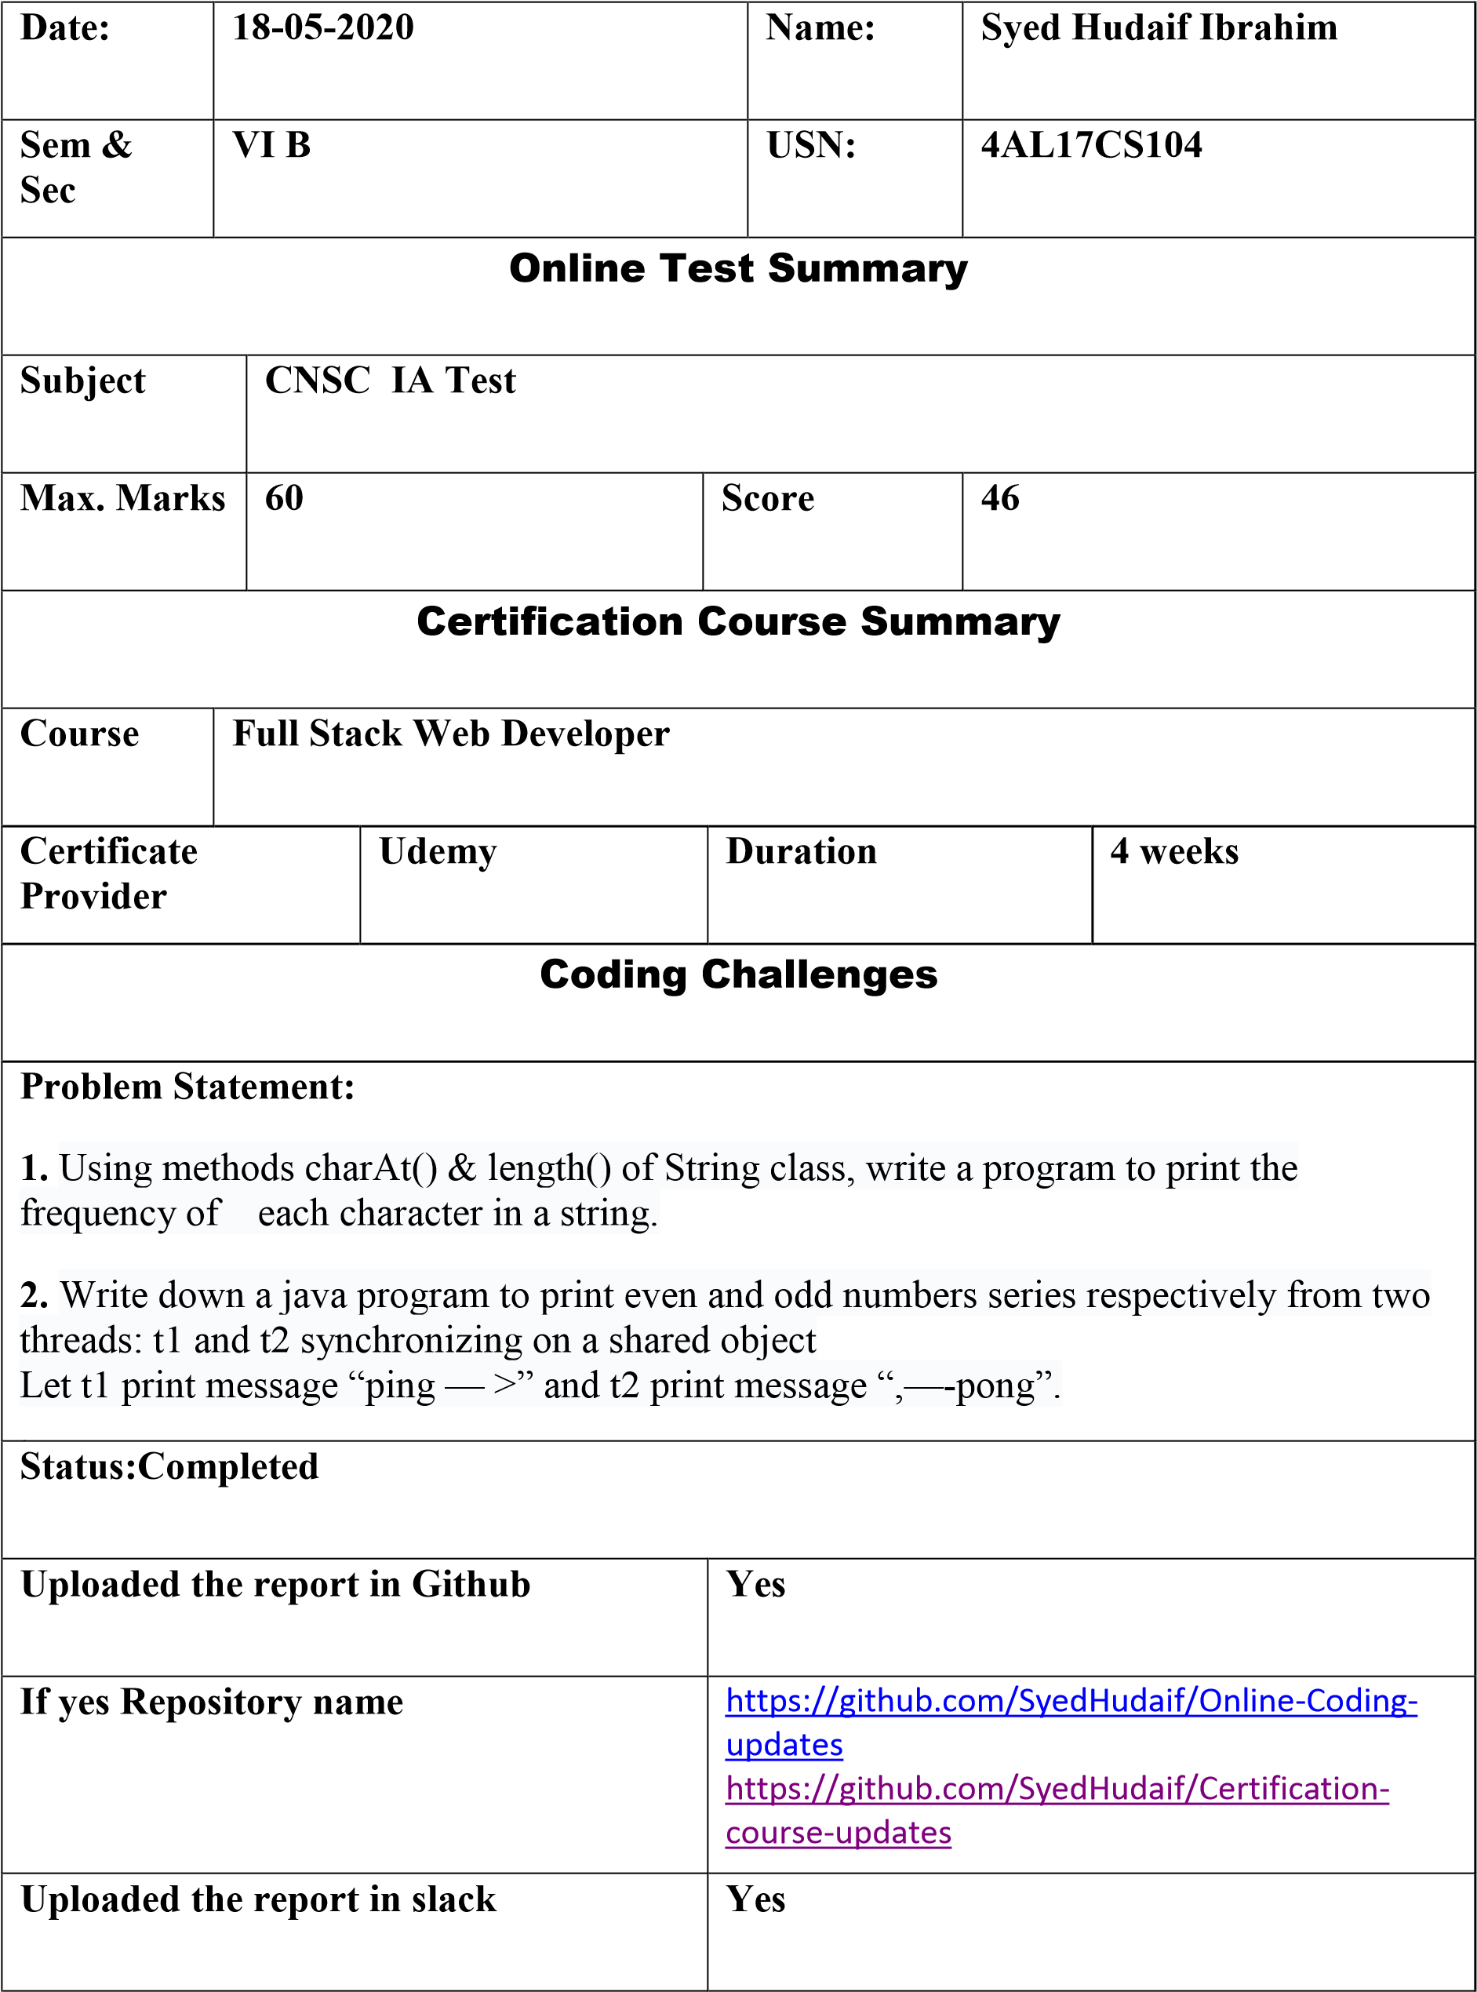

**Online Test Details**

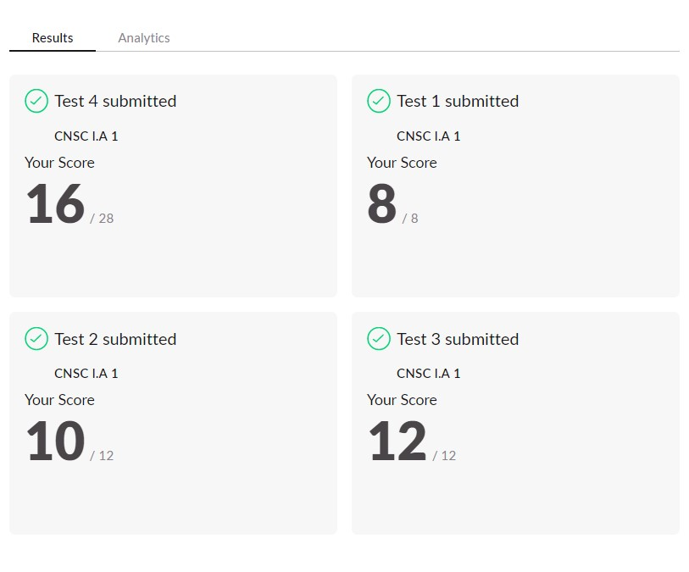

**Online**

**Certification**

**Details**

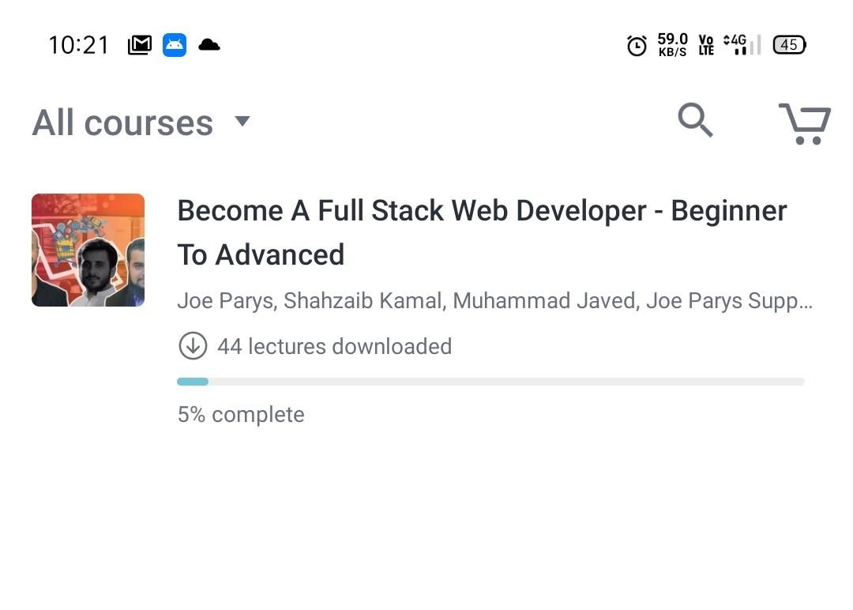

**Coding Challenge Details**

1. Using methods charAt() & length() of String class, write a program to print the frequency of each character in a string.

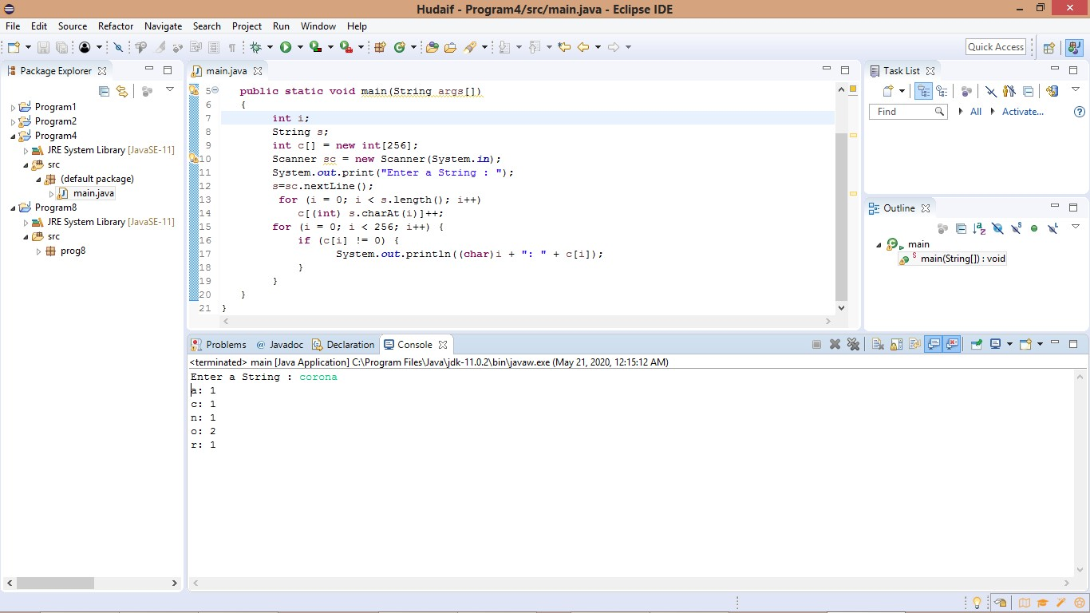

1. Write down a java program to print even and odd numbers series respectively from two threads: t1 and t2 synchronizing on a shared object

Let t1 print message “ping — >” and t2 print message “,—-pong”.

